Jenkins Assignment 5 using pipeline
Lauch instance and create pipeline job and build and run project which is in github .
Step -1 lauch instance install jave git and create build-tool and server folder inside mnt . then go inside build tool and wget maven then set environment inside vi .bash_profile then logout and login . after go server and wget tomcat 11 and goto bin and do ./startup.sh then goto webapp and get Jenkins
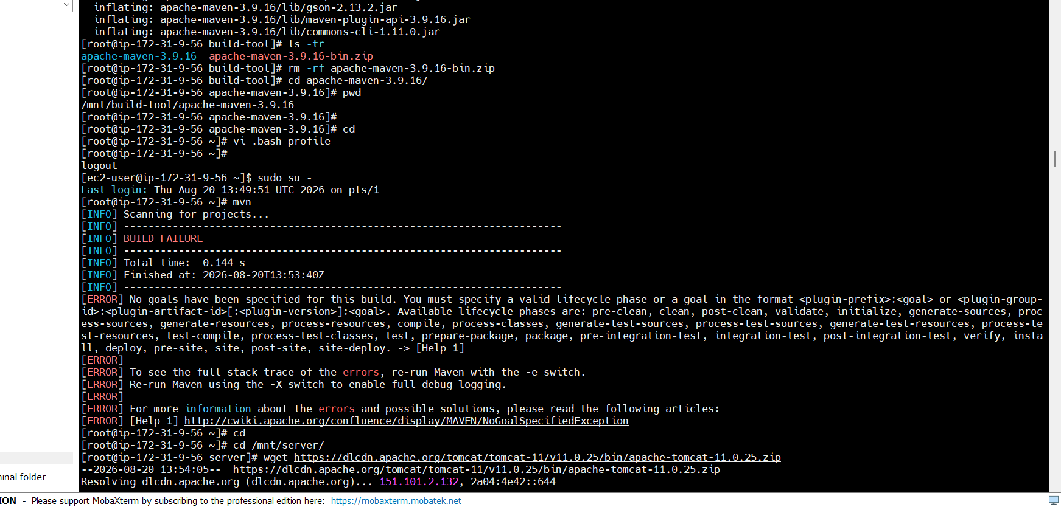
Step 2 – open Jenkins dashboard and goto manage Jenkins and then go inside tools and add maven
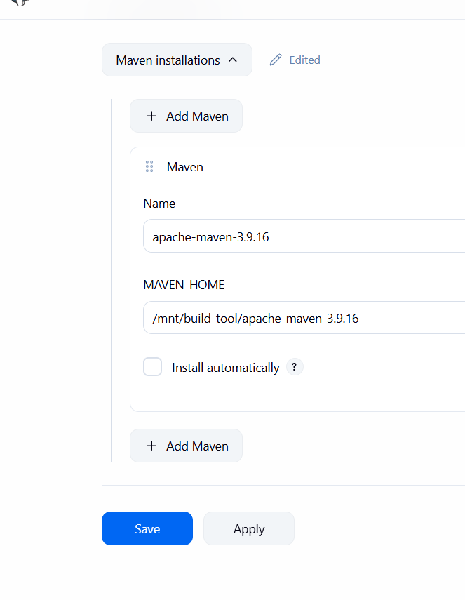
Step 3 – then create pipe line and add code
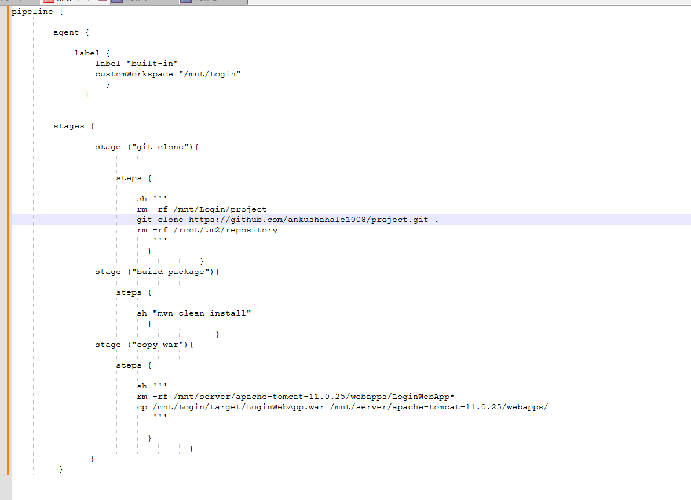
Step 4 then apply and save job and click on build now then check using url
http://ip:8080/projectname
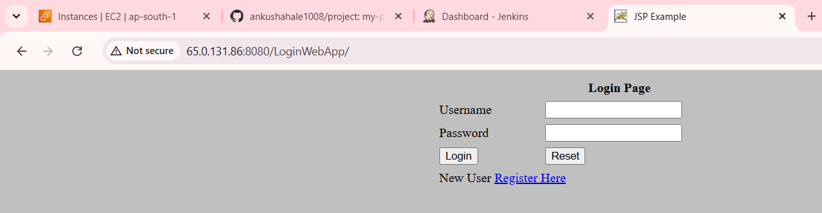
DoneSuccessfully.

